5-3 Activity: Visualize the Insight: Exploring Patterns with Python
Explanation of the types of charts you used: A dendrogram was utilized to visually depict the hierarchical relationship determined by using Ward’s method, showing the breakdown of the four main clusters, please see Figures 1 and 2. A PCS scatterplot was utilized to condense the 1,000 rows of information into a smaller set of uncorrelated variables, represented as the first and second principal components (IBM, n.d.), please see Figure 3. A cluster size distribution shows the allocation of 1,000 rows of data to the four clusters. It agrees with the output of the hierarchical clustering using Ward’s method, please see Figures 1 and 4. A feature importance heatmap of the cluster data shows the relative importance of a column in the dataset based on the coloring present at the intersection of the y-axis and x-axis, where the y-axis shows the cluster number and the x-axis shows the given column in the dataset, please see Figure 5. The trend charts represent the mean federal loan balance, the median income one year after graduating, and the number of degrees from the first and second year of the data collection by cluster category, please see Figure 6. Scatter plots were used to demonstrate the relationship between the median income earned one year after graduation versus three years after graduation and the median income earned one year after graduation versus the mean federal student loan balance and by cluster category, please see Figures 7.
Explanation of how your formatting decisions support visual clarity: The use of distinct and easy to see colors; the incorporation of y-axis and x-axis labels; titles; and legends enhanced the ease of use of the figures by aiding the user in being able to determine the information being presented by the given graph. Additionally, using consistent coloring across figures made it easier to compare the clusters across different figure types.

References

IBM. (n.d.). What is principal component analysis (PCA)? Retrieved from IBM: https://www.ibm.com/think/topics/principal-component-analysis

Figures
Figure 1: Hierarchical Clustering using Ward’s Method Output
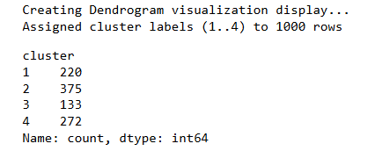
Figure 2: Dendrogram
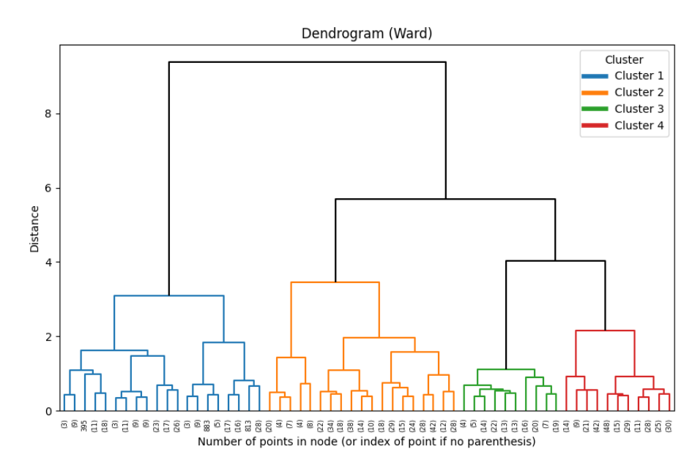

Figure 3: PCA Scatterplot
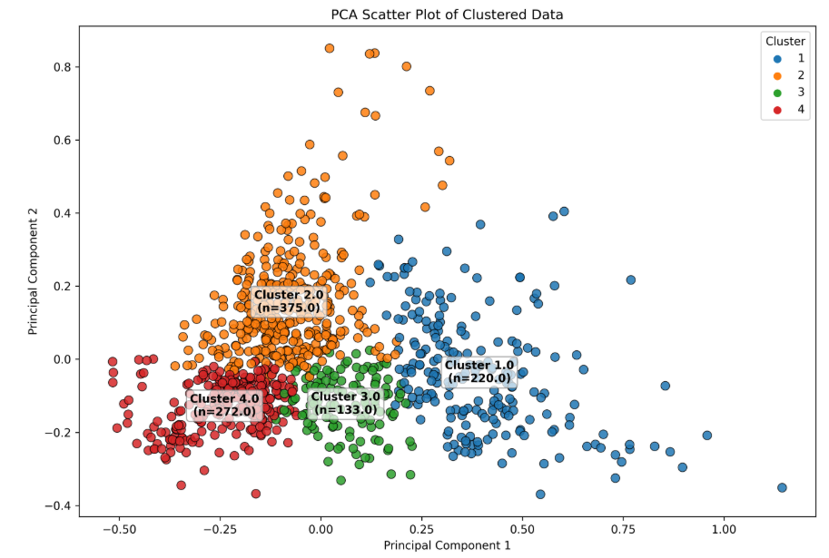

Figure 4: Cluster Size Distribution
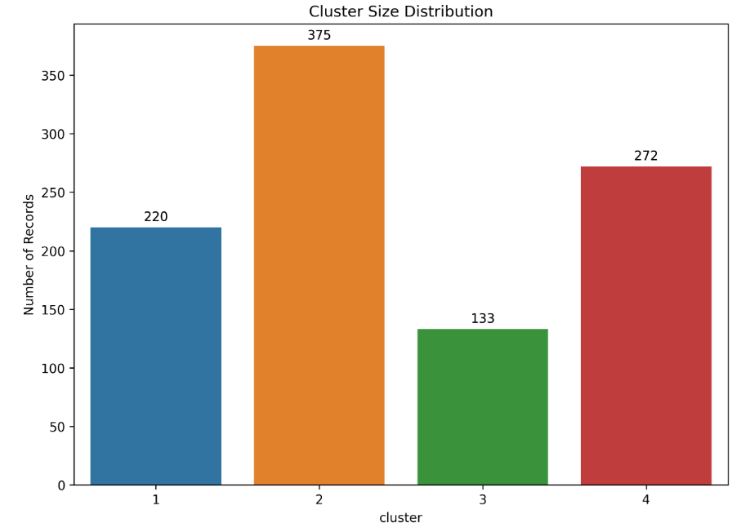

Figure 5: Feature Importance Heatmap
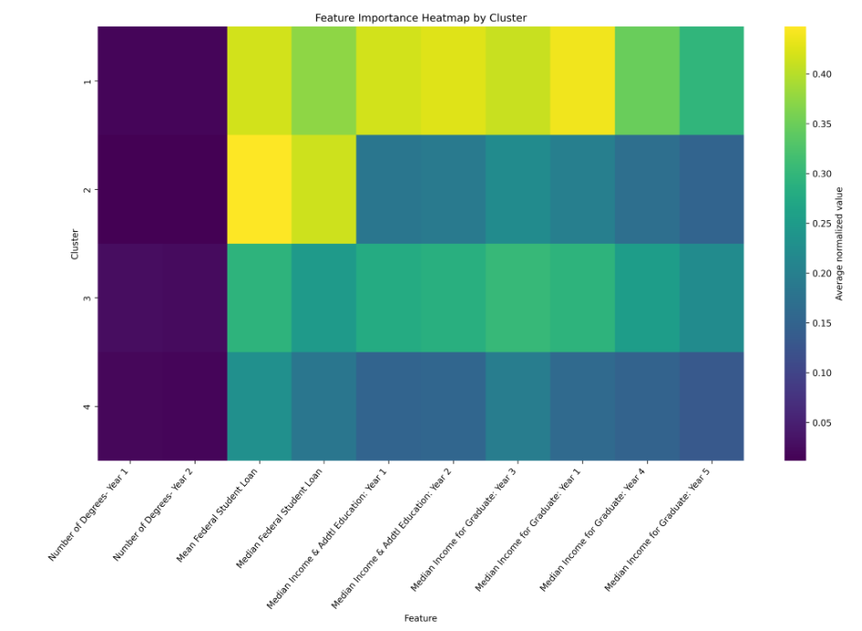

Figure 6: Trend Charts
Figure 6.1: Trend Chart- Mean Federal Loans
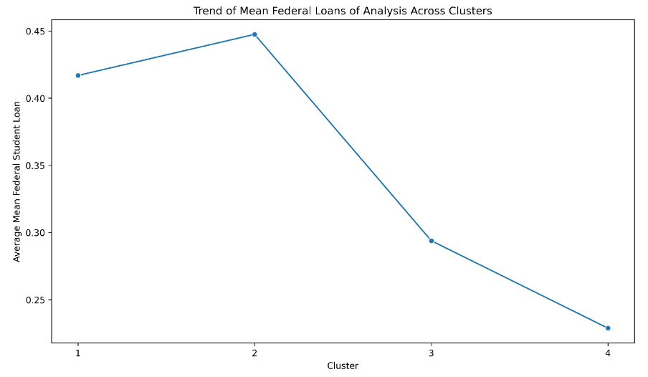
Figure 6.2: Trend Chart- Median Income 1 Year After Graduation
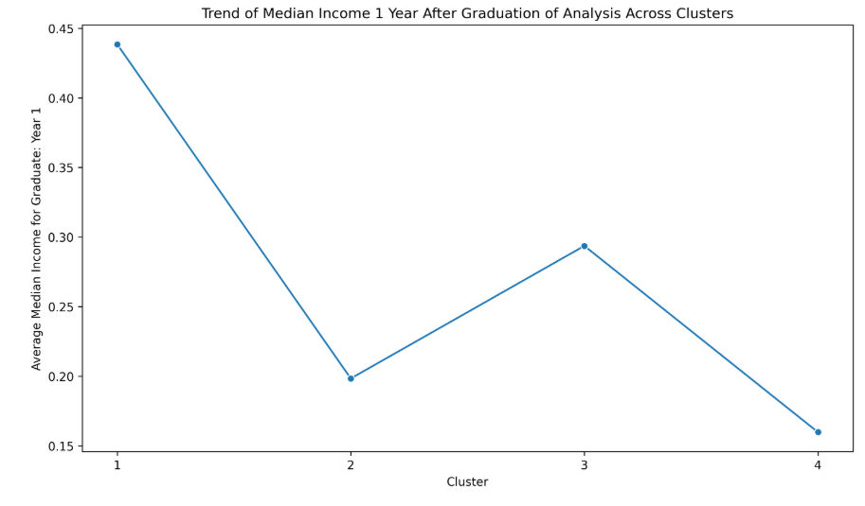
Figure 6.3: Trend Chart- Number of Degrees in Year 1 and Year 2
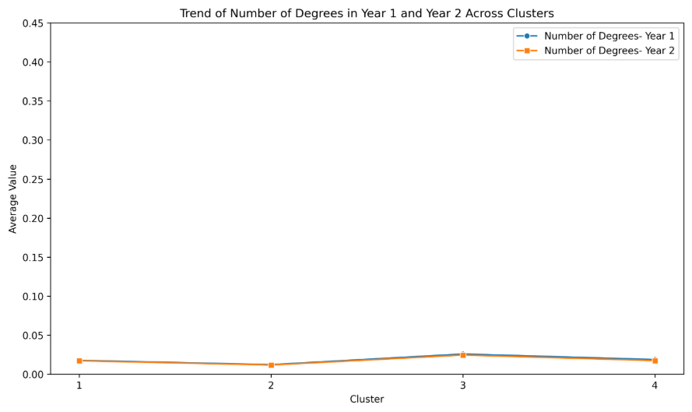

Figure 7: Scatterplots
Figure 7.1: Scatterplot- Income Received in Year 1 vs Year 3
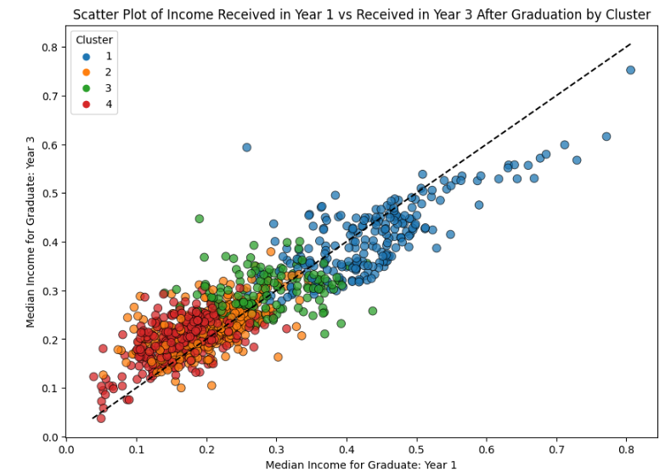
Figure 7.2: Scatterplot- Income Received in Year 1 vs Mean Federal Student Loan Debt
